Project 2

Gage Farmer - ECE 3561
March 8rd, 2024

sequential.vhd

----------------------------------------------------------------------------------
-- Company: Ohio State University
-- Engineer: Gage Farmer
--
-- Create Date: 16:08:11 03/06/2024
-- Design Name: Project 2
-- Module Name: wave - Behavioral
-- Project Name: 2
-- Target Devices: Xilinx for Windows on Linux (via Wine Compatability Shell)
-- Tool versions: 14.7
-- Description: Designed to be a simple sequential machine
--
-- Dependencies: ieee
--
-- Revision: 1
-- Revision 0.01 - File Created
-- Additional Comments: Hi Drew
--
----------------------------------------------------------------------------------
LIBRARY ieee;
USE ieee.std_logic_1164.ALL;
USE ieee.numeric_std.ALL;

ENTITY sequential IS
PORT( Q0 : OUT STD_LOGIC;
Q1 : OUT STD_LOGIC;
RCO : OUT STD_LOGIC;
CLK : IN STD_LOGIC;
INPUT : IN STD_LOGIC;
CLR : IN STD_LOGIC);
END sequential;

ARCHITECTURE behavioral OF sequential IS

SIGNAL CE1 : STD_LOGIC:= '1'; -- Clock Enable for Flip Flop 1
SIGNAL CE0 : STD_LOGIC; -- Clock Enable for Flip Flop 0
SIGNAL IQ0 : STD_LOGIC:='0'; -- Interior output Q for Flip Flop 0
SIGNAL IQ1 : STD_LOGIC:='0'; -- Interior output Q for Flip Flop 1

BEGIN
process (IQ0,IQ1,INPUT) -- output 1) the 3-8 decoder 2) Q0 3) Q1
begin
if IQ0='1' and IQ1='1' and INPUT='1' then
RCO <= '1';
elsif IQ0='0' and IQ1='0' and INPUT='0' then
RCO <= '1';
else
RCO <= '0';
end if;
Q0 <= IQ0;
Q1 <= IQ1;
end process;

process (CLK, CLR) -- The first T flip-flop
begin
if (CLK'event and CLK='1') then
if CLR = '1' then
IQ1 <= '0';
elsif CE1 = '1' then
IQ1 <= not(IQ1);
end if;
end if;
end process;

process (CLK, CLR) -- The second T flip-flop
begin
if INPUT='1' and IQ1='1' then
CE0<='1';
elsif INPUT='0' and IQ1='0' then
CE0<='1';
else
CE0<='0';
end if;

if CLK'event and CLK='1' then
if CLR='1' then
IQ0<='0';
elsif CE0='1' then
IQ0<=not(IQ0);
end if;
end if;
end process;

END;

Waveform Diagram

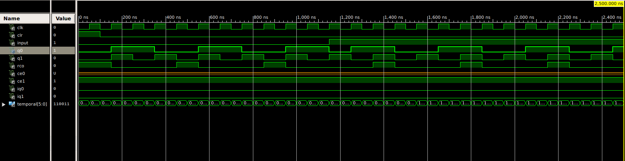

State Diagram

